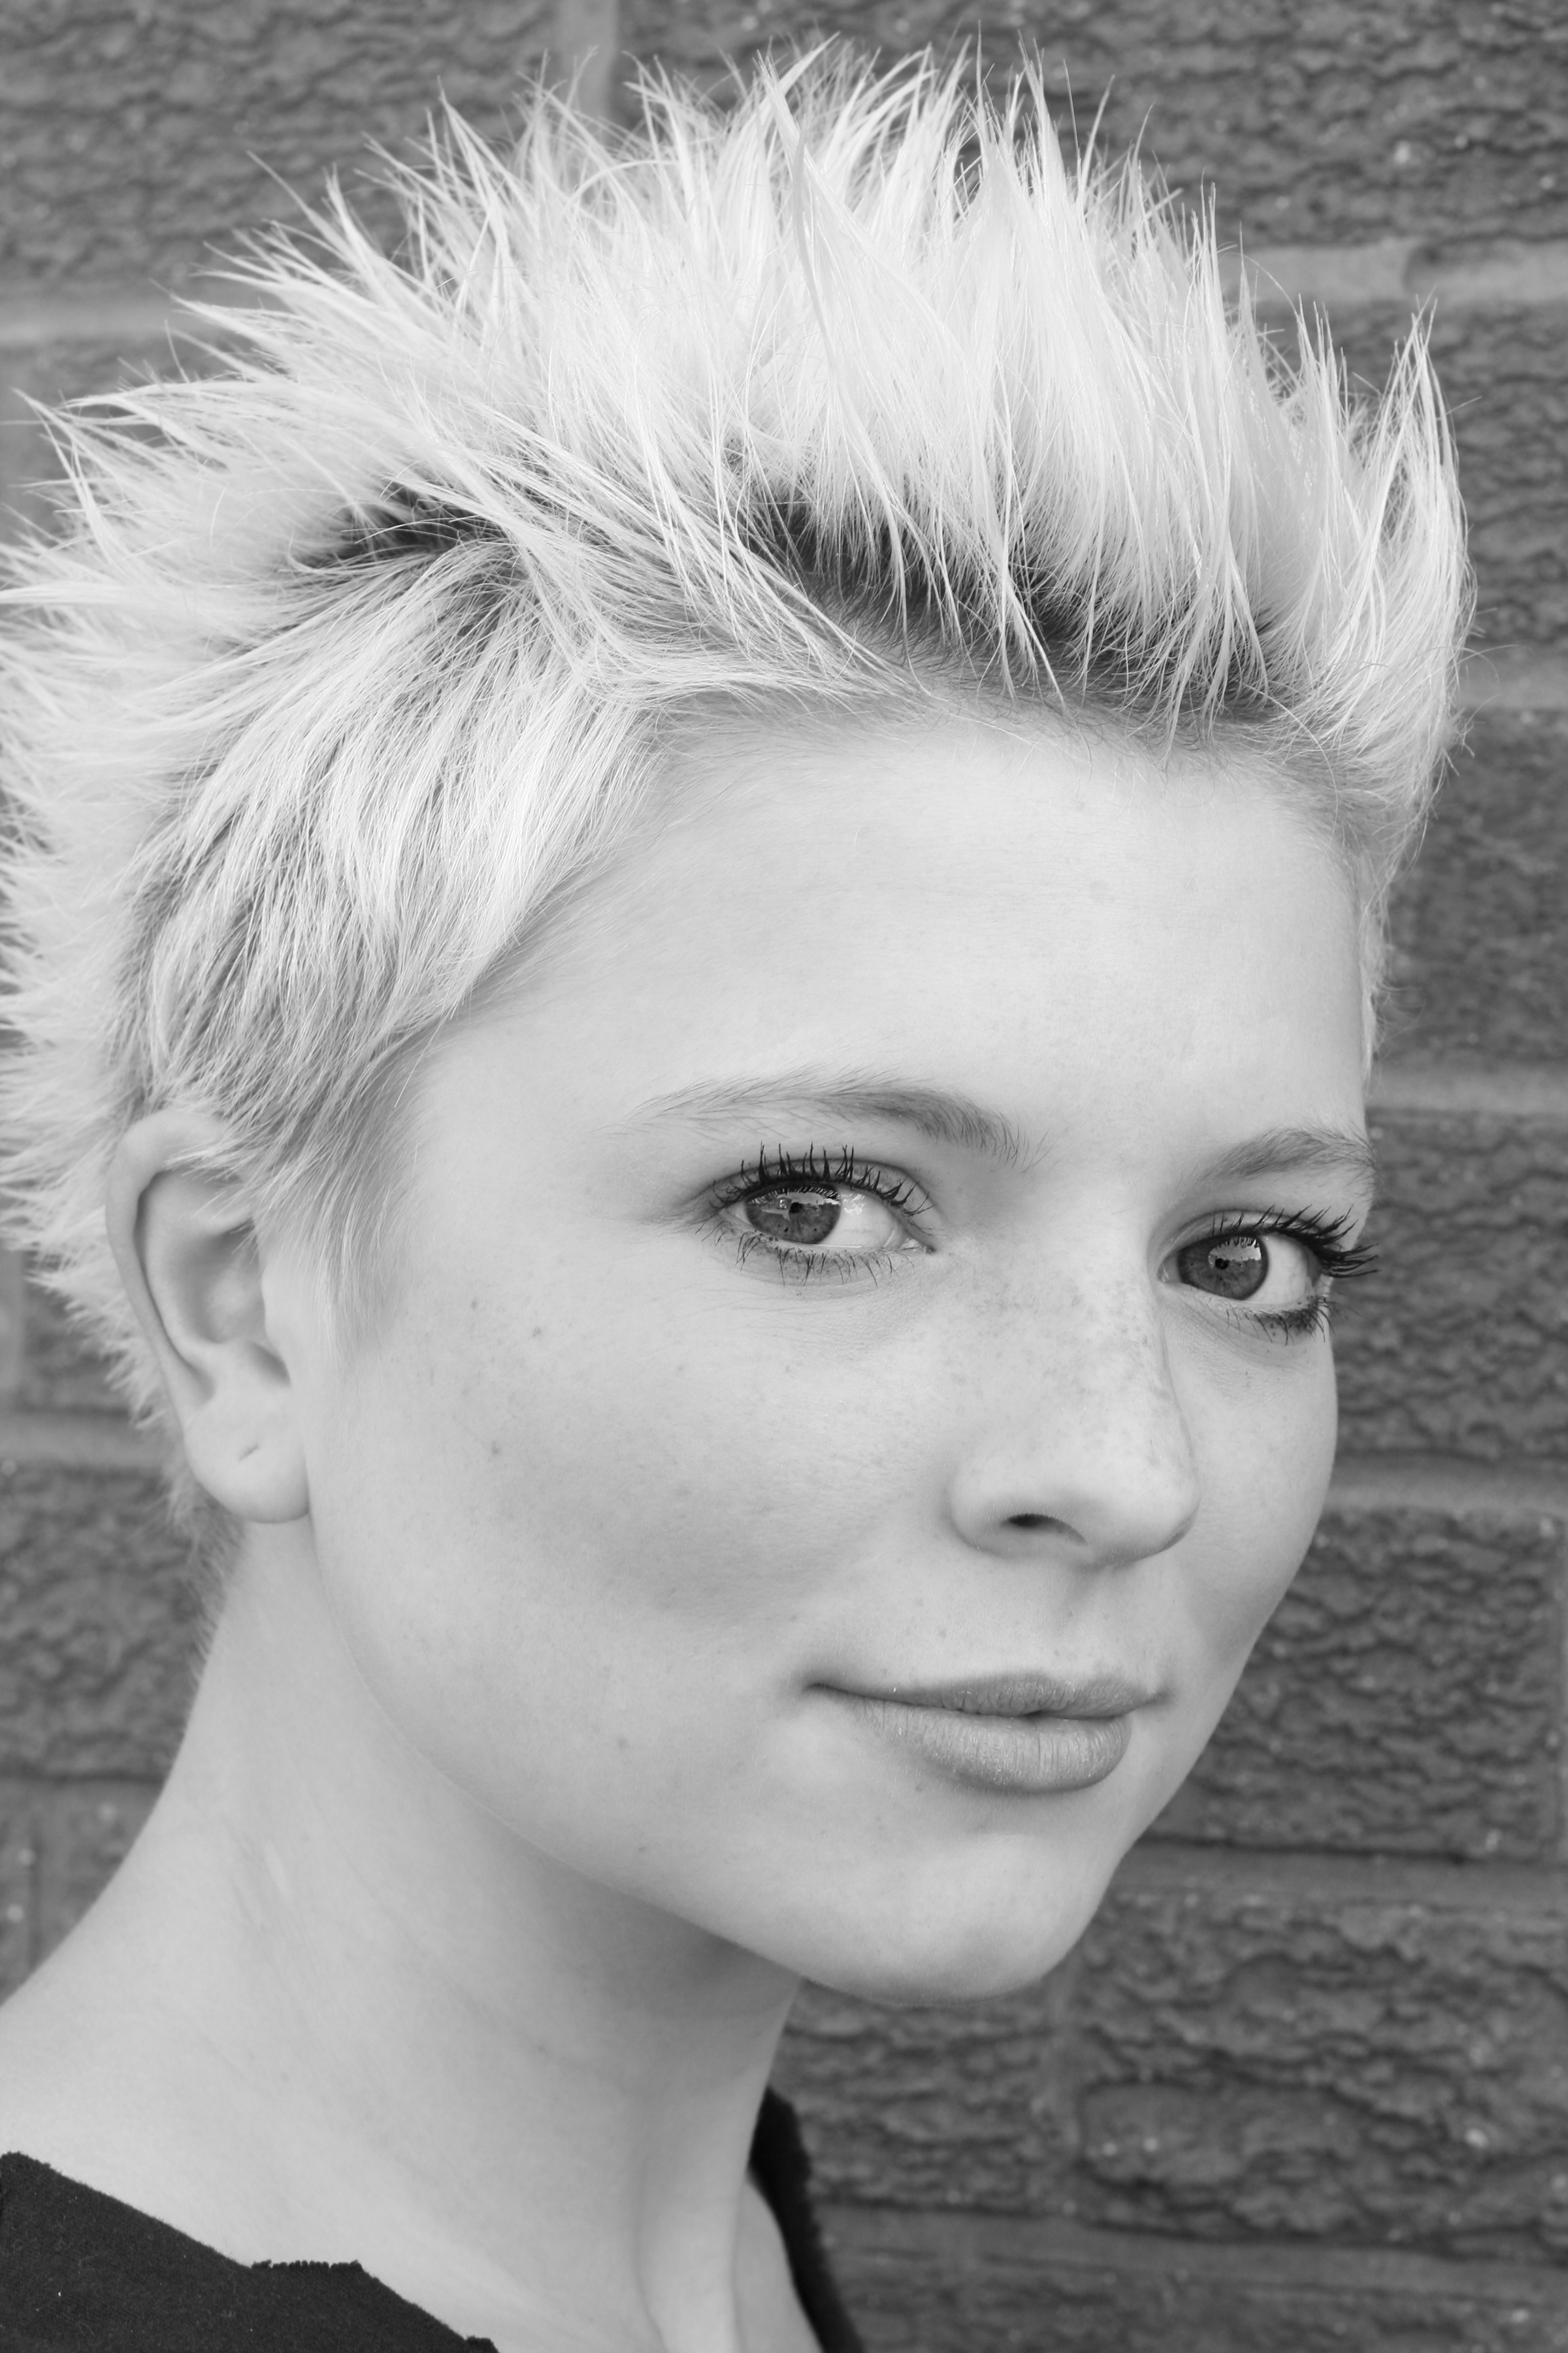Jessica Harper

Contact: 54 Alexandra Road, Penn, Wolverhampton, West Midlands. WV4 5UB.
Mobile: 07776414093
Email: jessica-harper@hotmail.com
Agent: JAA Associates
Height: 5’6”
Build: Slim
Hair: Strawberry Blonde
Eyes: Brown

Accents: Northern, Cockney, Scouse, Midlands, R.P/Standard/Neutral, American (various regions)

Playing Age: 15-24

T.V and Film Credits:
Year Type Role Production Company Director

2011 Education Film Public What You Lookin At? Urban Voice Limited Karl Veltman

2007 BBC Film Tanya Filth Wall To Wall Andy de Emmony

2007 Short film 3rd soldier 3 Soldiers go to war Lighthouse Cinema Dianne Knox
2007 Advert Extra Don’t be a clown Lighthouse Cinema Dianne Knox
2005 Television Keeley Doctors: Sport For All BBC Paul Gibson
2004 Television Nicki Dalziel And Pascoe: Great Escape BBC Colyn Buchanan
2004 Television Sophie Casualty: Where There’s Life BBC Jane Powell
2002 Short Film Daughter Time To Save The World Zeno Films Adam Trotman

Theatre and T.I.E Credits:

2009 Theate Various The Corner Shop Foursight Theatre Steve Johnstone

2008 T.I.E Jenny Mane Street Urban Voice Limited Nicola Byrne

2008 T.I.E Teacher in Role Secrets Midland Actors Theatre David Alan
2007 T.I.E Spot The Dog Mane Street Urban Voice Limited Nicola Byrne
2007 Theatre Cath Ruckus In The Garden ITV T.V Workshop Colin Edwards
2007 Theatre Dodger Oliver S.S.M.T.C Lindsay Flavell

2006 Theatre Fleance Macbeth Troika Productions Stephen Barnes
2006 Theatre Numerous 15 Yards ITV T.V Workshop Ian Smith
Training:
2000 – 2009: ITV Children’s Television Workshop
2006 – 2008: BTEC National Diploma Performing Arts: Triple Distinction Award

Skills:
Full Driving License, Acoustic Guitar, Tap and Jazz Dancing Grade 5, Rollerblading, Workshop Facilitation Skills with Children and Adults with Learning Difficulties,
Skin work, Mask Work and Puppetry.

